**Improving Nutrition for Women and Children in Western Kenya**

STIPA in partnership with SACK organization works in Busia county – Matayos and Teso South sub counties –Busibwabo and Ang’orom ward. Bungoma county- Bumula sub county, Kimaeti ward with a target of 20,800 beneficiaries to access quality and affordable health care through health financing, So far we have 4,285 beneficiaries accessing quality and affordable health care.

Scheme working with JAKA, Nakhakina, Nasira, Karuchokinosi, Amani, Alung’oli , Matunda, Bitobo, Masielo, Nakhwana, Napara and Syombe.

The project has so far Achieved the following: a total of 5 GMCs(Bungoma) and 7 GMCs (Busia ) reached, a total number of 732 households for 2019/2020 and 825 registered in 2020/2021,

Number of people accessing treatment 2019/2020 was 1,645 beneficiaries while in 2020/2021 we have 2,640

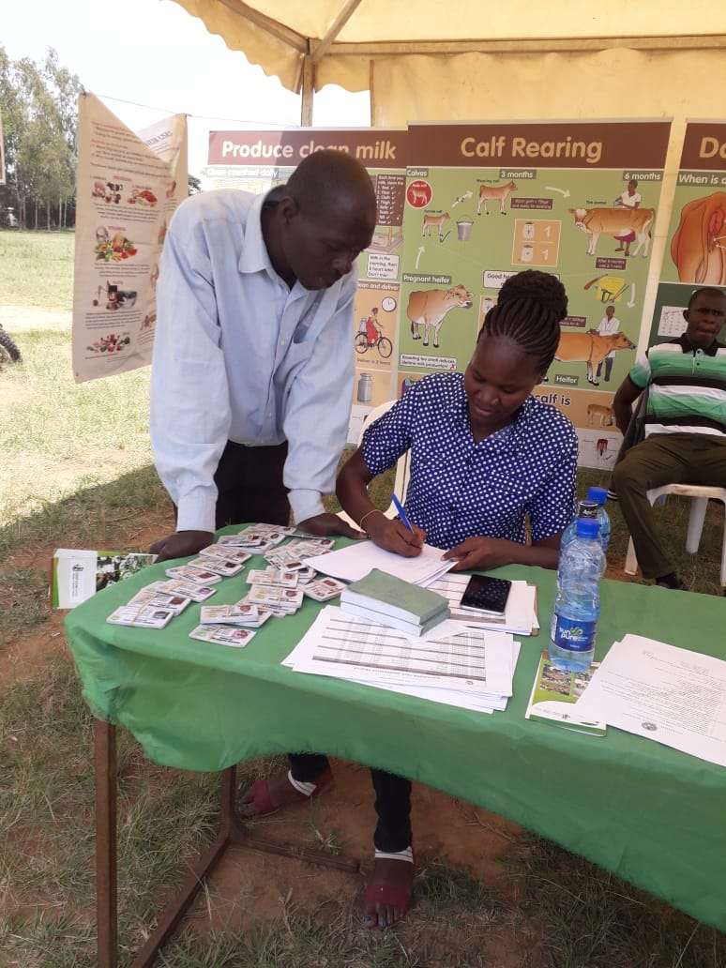

CBHF cards distribution in Bungoma county

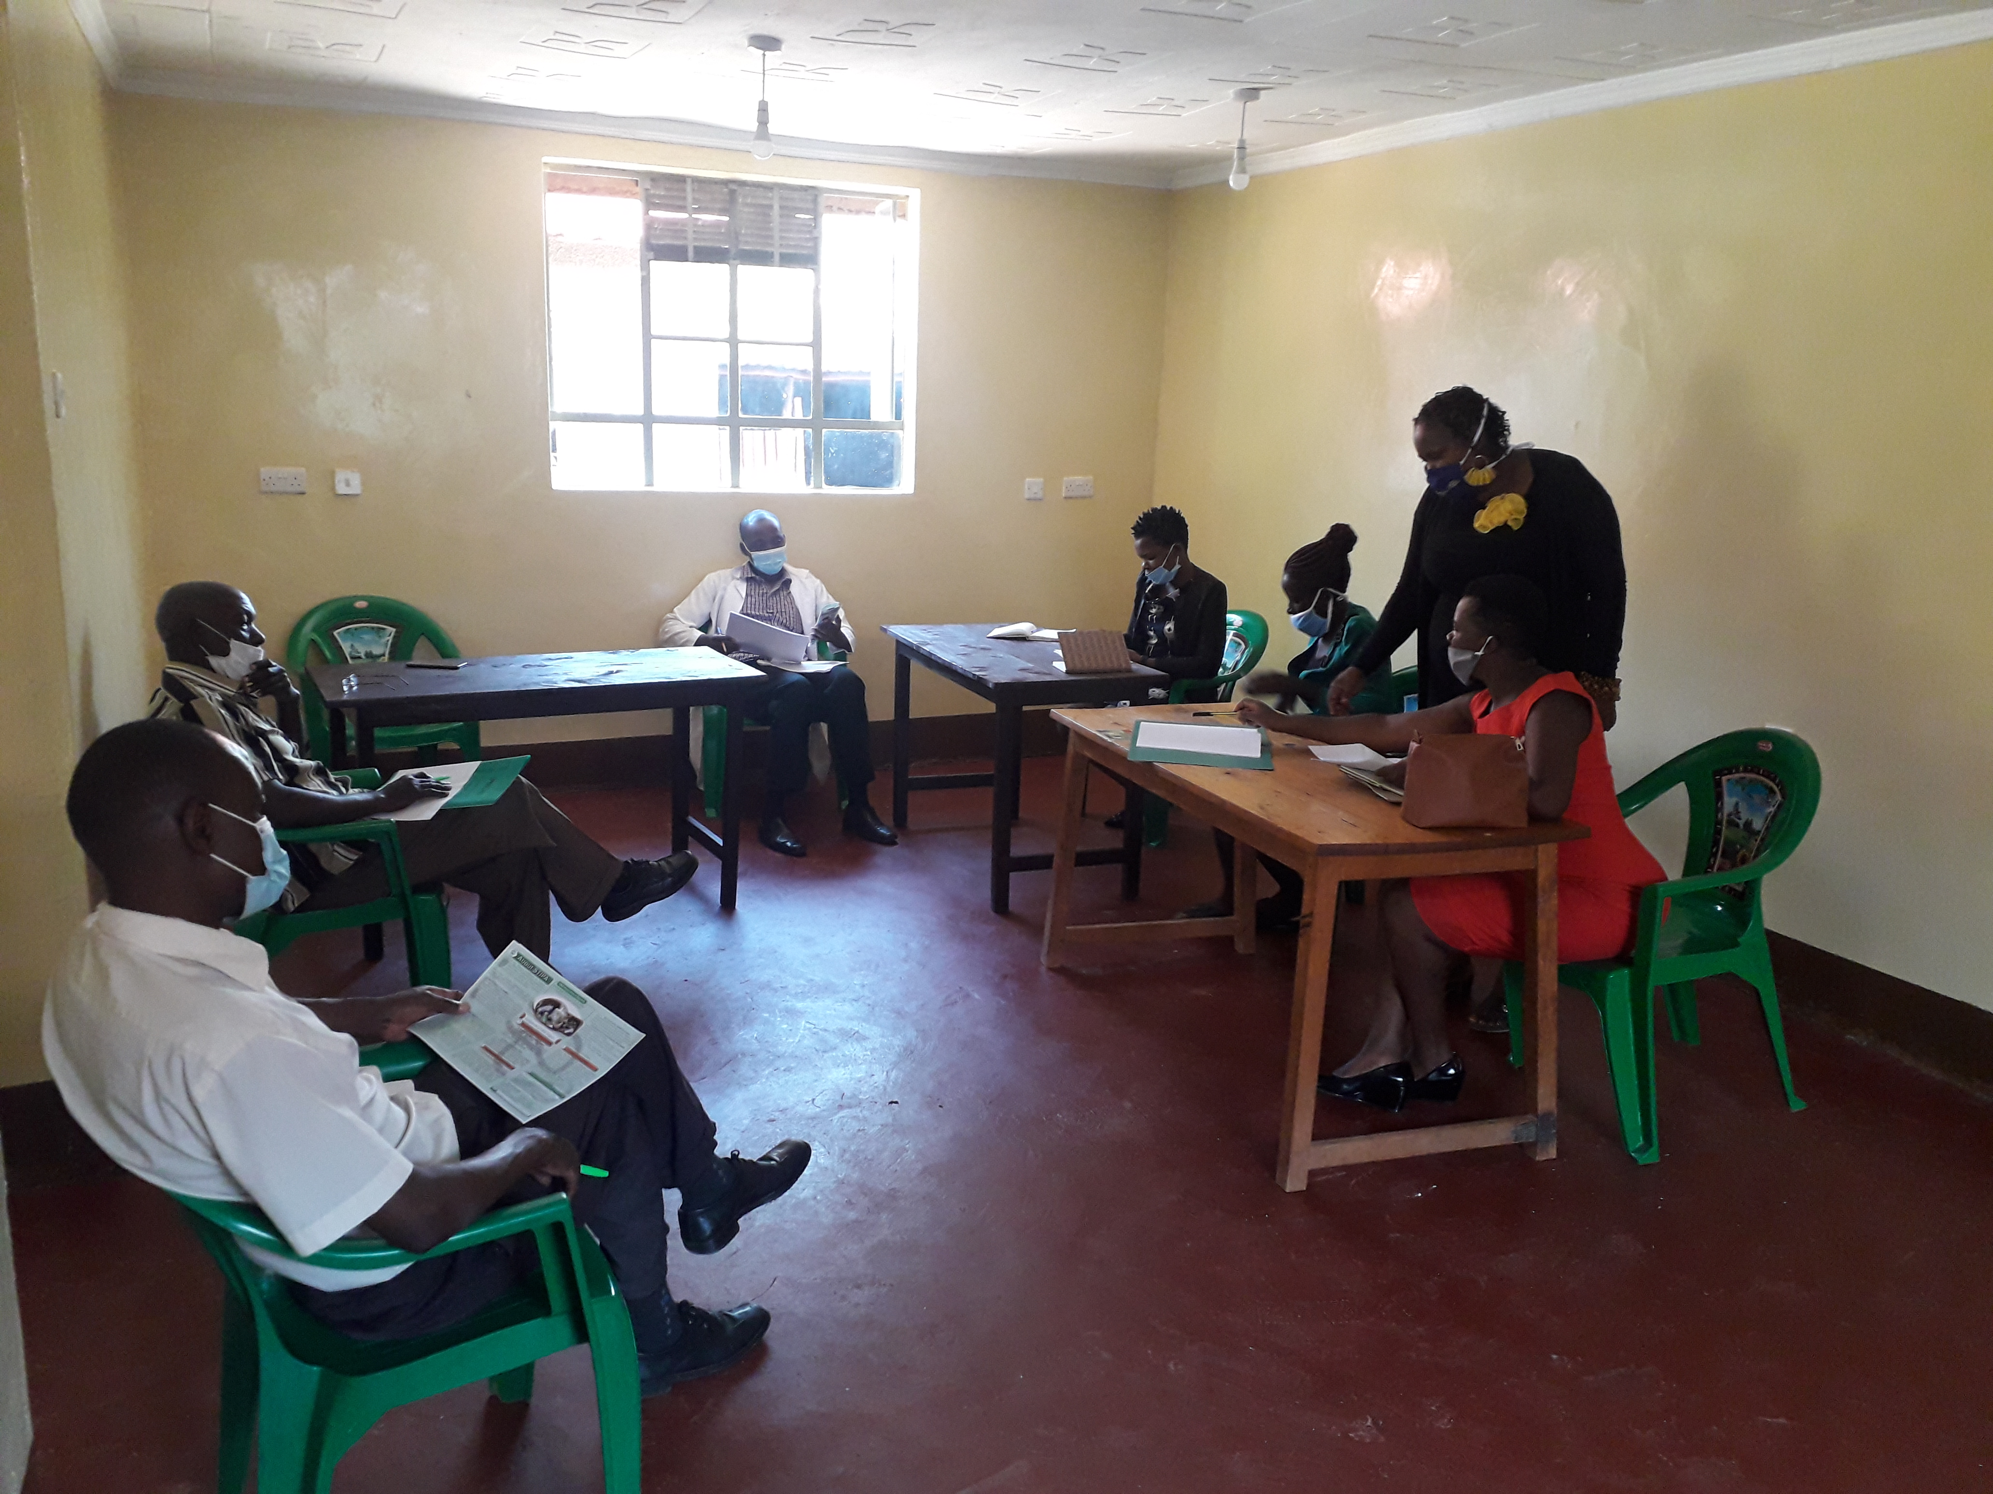

MOU negotiation with Ember health facilities

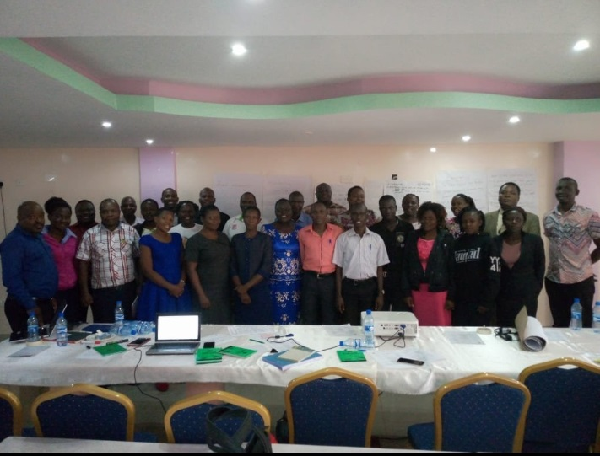

Photo session with the Busia Bungoma Health Providers